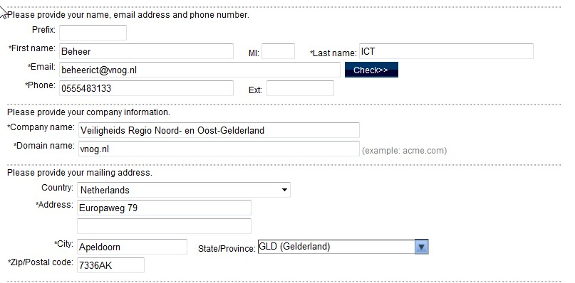

# HP Thin Provisioning P6300 Unlim
YB3A B99A H9PA CHXY URA4 HW6V Y9JL KMPL B89H MZVU DXAU 2CSM GHTG L762 AWG7 VEZU KJVT D5KM EFVW TSNJ LCX8 PQW2 QPSL YGWK PLYM LVBJ U3SP QYTX Q3ND 7AX9 7FU3 TVUD APN5 EEP2 D8EW R42A M6VG JSSY EZNC J89E 4MNA 9GGR EZU7 GEMX 5XYT CC5N PWRK KESY AK92 7FTA "PRQ797K5H4 TA810A#2 HP Thin Provisioning P6300 LTU"

# HP Dyn Cap Mgmt EVA P6300 Unl
ABLA B99A H9P9 GHU2 U5A5 HW2N Y9JL KMPL B89H MZVU DXAU 2CSM GHTG L762 YWG7 XEJU KJVT D5KM EFVW TSNJ LCX8 PQW2 QPSL YGWK PLYM LVBJ U3SP QYTX Q3ND 7AX9 7FU3 TVUD APN5 EEP2 D8EW R42A M6VG JSSY EZNC J89E 4MNA 9GGR EZU7 GEMX 5XYT CC5N XWRK KESY AK92 7FTA "PRQ797K5H4 TA810A#3 HP Dynamic Cap Mgmt P6300 LTU"

# HP CV P6300 Unlimited
9CYE DQ9A H9PA KHX2 VFA5 HWWF Y9JL KMPL B89H MZVU DXAU 2CSM GHTG L762 EWW7 FEJM KJVT D5KM EFVW TSNJ 3CP8 NQG2 QPSL YGWK PLYM LVBJ U3SP QYTX Q3ND 7AX9 7FU3 TVUD APN5 EEP2 D8EW R42A M65A KSSY ESJA 8BDL YRYX QKE8 UAE6 HPH3 MUQK WJAG FSRV RCLU YJ9Y 4CNN 3EJF Z9M5 NU3J EQEM USCQ VBTA 5625 P2XE "PRQ797K5H4 TA810A#1 HP P6300 Command View SW LTU"

