

Hyper-V
Systeem Documentatie



.datum | 2 oktober 2012
.op verzoek van | VNOG
.versie | 1.0
.documentreferentie | SD20120724JSl(Inrichting Hyper-V)v1.0.docx

Disclaimer

Alle rechten voorbehouden. U ontvangt dit document onder de uitdrukkelijke voorwaarde dat u dit document vertrouwelijk zal behandelen en dat, indien u niet wenst in te gaan op dit document, van de inhoud geen gebruik zal maken zonder voorafgaande schriftelijke toestemming van PeopleWare ICT Solutions. Tevens is het niet toegestaan dit document op enigerlei wijze aan derden ter beschikking te stellen zonder voorafgaande schriftelijke toestemming van PeopleWare ICT Solutions. PeopleWare ICT Solutions behoudt zich alle rechten voor ter zake auteursrecht rustende op dit document. Alle genoemde handelsmerken in dit document zijn eigendom van de rechthebbenden.

Dit document is gebaseerd op informatie die is verstrekt door u en PeopleWare ICT Solutions kan niet garanderen dat deze informatie correct en/of compleet is. Omdat PeopleWare ICT Solutions de veranderingen in techniek en de wijzigingen in de computer- en netwerkomgevingen van klanten volgt, dient dit document niet te worden opgevat als een verbintenis of toezegging van PeopleWare ICT Solutions.

© 2012, PeopleWare ICT Solutions

Documentenbeheer
Versiebeheer

Versie | Auteur |  | Aanpassingen |  |  | Datum
0.1 | Johan Sleeuwenhoek |  | Eerste versie. |  |  | 26-07-2012
1.0 | Johan Sleeuwenhoek |  | Review |  |  | 02-10-2012
Document review & distributie

Naam reviewer |  | Organisatie |  | E-mail adres |  | Review datum
Documentgoedkeuring

Naam |  | Handtekening |  |  | Datum

Inhoudsopgave

Hoofdstuk 1 Parameters 5
1.1 Hyper-V Nodes 5
1.2 Patches en hotfixes 5
Hoofdstuk 2 Hyper-V 7
2.1 Bios configuratie 7
2.2 Netwerk configuratie 7
2.3 Voorbereidingen 9
2.4 Cluster en Hyper-V 10
Hoofdstuk 3 Passthrough Disks 11
Bijlage 1 IP Configuratie 17
Bijlage 2 Netwerkconfiguratie 18
Bijlage 3 AntiAffinity 22

- Parameters

Zie Implementatie Specificaties.

- Hyper-V Nodes

Functie | Database Server

- Patches en hotfixes

Patch | Omschrijving
KB2520155 | DNS Host record of a computer is deleted after you change the DNS server assignment
KB2541014 | Hibernation does not work or memory dump file is not created after you install Windows 7 or Windows Server 2008 R2 Service Pack 1
KB2525835 | MS11-047: Vulnerability in Microsoft Hyper-V could cause denial of service: June 14, 2011
KB2559392 | The List Running Processes test fails when you run the Failover Cluster Validation Wizard on a Windows 7-based or Windows Server 2008 R2-based cluster node
KB2586470 | A saved virtual machine crashes on resume when it hits a debugging breakpoint in Windows Server 2008 R2
KB2614892 | A computer stops responding because of a deadlock situation in the Mountmgr.sys driver in running Windows 7 or in Windows Server 2008 R2
KB2636573 | FIX: The guest operating system may crash when you perform a live migration of Hyper-V virtual machines in a Windows Server 2008 R2 environment
KB2639032 | "0x0000003B," "0x00000027," and "0x0000007e" Stop errors when a connection to a CSV is lost on a Windows Server 2008 R2-based failover cluster
KB2654363 | Computer crashes when you use Driver Verifier to monitor Storport.sys if you disable the HBA in Windows 7 or Windows Server 2008 R2
KB2662288 | A differencing VHD file that is created by using Microsoft iSCSI Software Target 3.3 becomes corrupted when you mount or attach it in Windows Server 2008 R2 or in Windows 7
KB2668084 | Virtual machine is restored in the Saved state incorrectly on a Hyper-V server that is running Windows Server 2008 R2
KB2685891 | CAP does not come online in a Windows Server 2008 R2-based failover cluster
KB2687646 | A LUN that is registered to a cluster shared volume is invisible and inaccessible in a Windows Server 2008 R2
KB2692929 | "0x80041001" error when the Win32_Environment WMI class is queried by multiple requestors in Windows 7 or in Windows Server 2008 R2
KB2699780 | Memory leak in the Remote Registry service on a computer that is running Windows 7 or Windows Server 2008 R2
KB2705742 | "0x0000003B" Stop error when you use a Citrix XenApp application in Windows 7 or in Windows Server 2008 R2
KB2708549 | Stop error when you create a VSS snapshot backup in Windows 7 SP1 or in Windows Server 2008 R2 SP1: "fvevol!FveFilterDeviceControl+1d0"
KB2708811 | Data corruption occurs when a sparse file undergoes random write stress in Windows 7 or in Windows Server 2008 R2
KB2708857 | RDX cartridge disks are not recognized correctly in Windows 7, in Windows Vista, in Windows Server 2008, or in Windows Server 2008 R2
KB2711774 | AltGr key does not work in a Red Hat Linux virtual machine on a Windows Server 2008 R2-based computer
KB2718576 | MPIO disk is removed unexpectedly when a PR_IN command fails in a Windows Server 2008 R2 environment
KB2722392 | "0x000000F4" Stop error when you run the Device Fundamental tests in Windows 7 or in Windows Server 2008 R2

- Hyper-V

- Bios configuratie

Scherm | Aktie
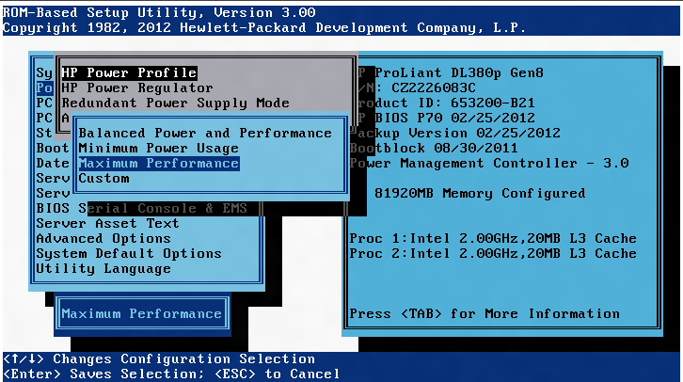 | Maximum Performance
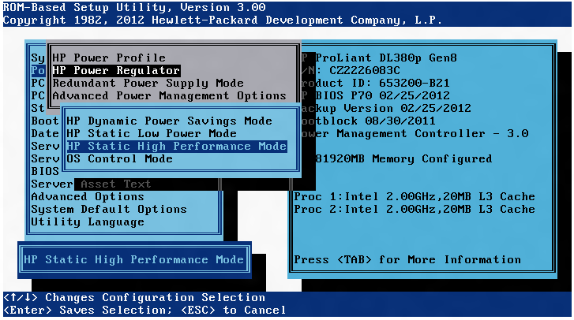 | HP Static High Performance Mode
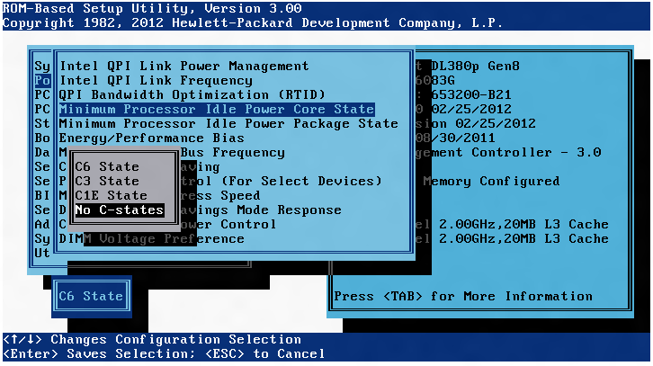 | No C-states

- Netwerk configuratie

Scherm | Aktie
netsh.exe int set int name="Local Area Connection 8" newname="Cluster"  netsh.exe int set int name="Local Area Connection 7" newname="Trunk"  netsh.exe int set int name="Local Area Connection 6" newname="Live Migration"  netsh.exe int set int name="Local Area Connection 5" newname="CSV"  netsh.exe int set int name="Local Area Connection 4" newname="NIC 7 - Disabled"  netsh.exe int set int name="Local Area Connection 3" newname="NIC 8 - Disabled"  netsh.exe int set int name="Local Area Connection 2" newname="Management"  netsh.exe int set int name="Local Area Connection" newname="Backup" | Hernoem de NICs  (dubbelcheck de exacte namen, deze kunnen afwijken)
Bijlage 1 | Zet IP adressen
Bijlage 2 | Draai het script van bijlage 1
 | Start hpteam.cpl
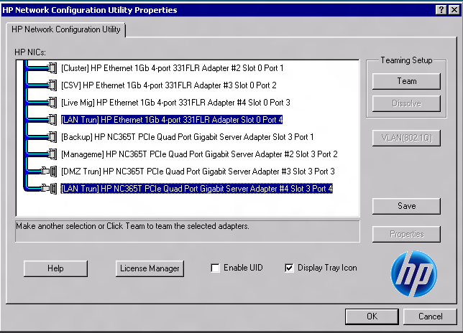 | Selecteer NIC4 en NIC8  Team
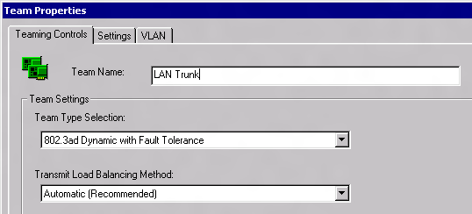 | Properties  TLB = TCP
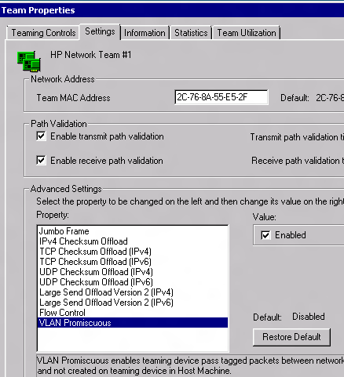 | VLAN Promiscuous Enabled
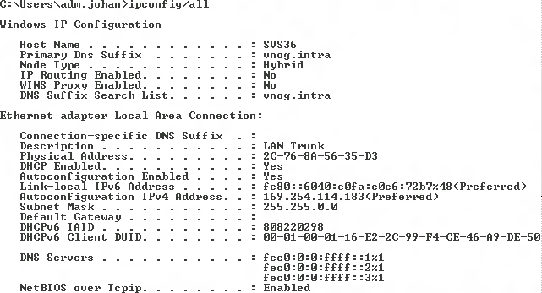 | netsh.exe int set int name="Local Area Connection X" newname="LAN Trunk"

- Voorbereidingen

Scherm | Aktie
C:\Install\cp015350.exe  C:\hp\hpsmh\bin\smhconfig.exe --ip-binding-list=  C:\hp\hpsmh\bin\smhconfig.exe --localaccess-enabled=true  C:\hp\hpsmh\bin\smhconfig.exe --localaccess-type=administrator  C:\hp\hpsmh\bin\smhconfig.exe --port2301=false  C:\hp\hpsmh\bin\smhconfig.exe --restart  netsh advfirewall firewall add rule name="HP System Management Homepage" dir=in protocol=tcp profile=any localport=2381 action=allow | HP WBEM agents en System Management Homepage
dism.exe /Online /Enable-Feature /FeatureName:Microsoft-Hyper-V /FeatureName:MultipathIo /FeatureName:WindowsServerBackup /FeatureName:FailoverCluster-Core | Windows 2008 R2 Componenten
mpclaim -r -i -a | MPIO configuratie

- Cluster en Hyper-V

Scherm | Aktie
Import-Module FailoverClusters
Add-ClusterNode -Name <server> -Cluster svs30

- Passthrough Disks

Scherm | Aktie
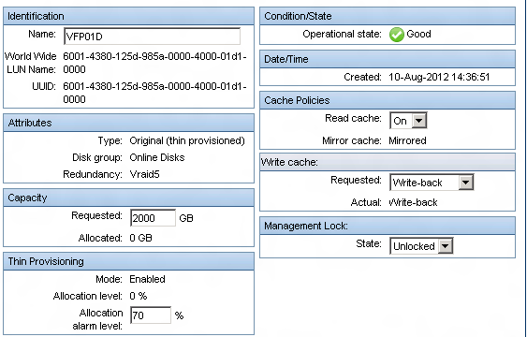 | Creeer de disk in Command View
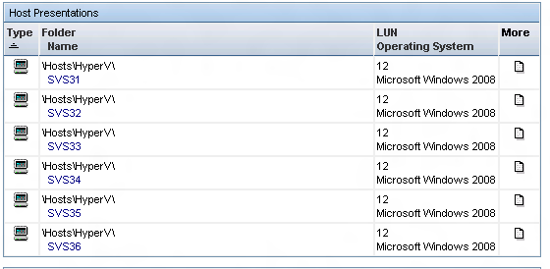 | Presenteer deze aan alle Hyper-V nodes
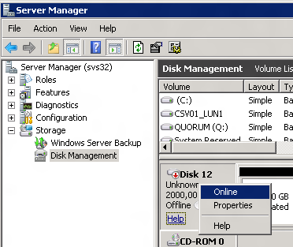 | Breng de LUN online
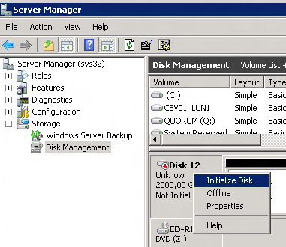 | Initialize Disk
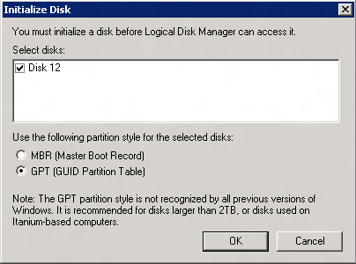 | GPT
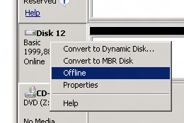 | Breng de Disk Offline
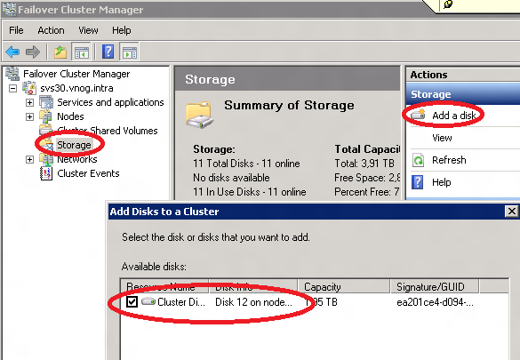 | Open Cluster Manager  Voeg de Disk toe
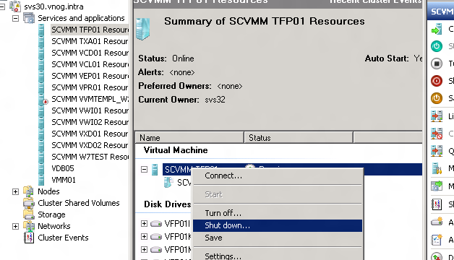 | Stop de VM waar de Disk aan moet komen
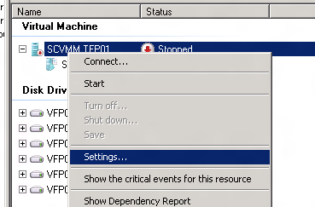 | Open de Settings
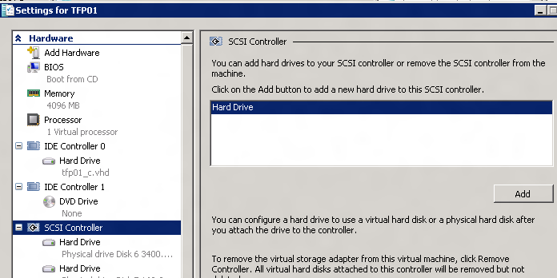 | Add de Disk
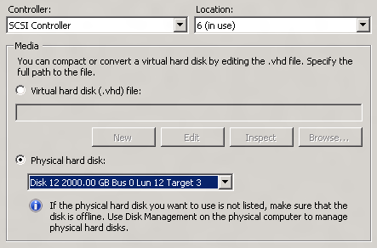 | Kies Physical hard disk
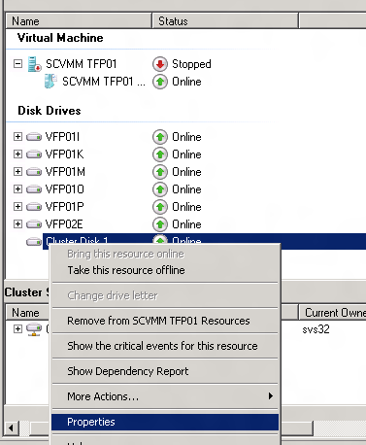 | Open de Properties van de Cluster Disk
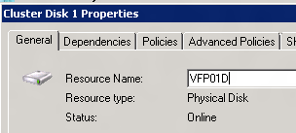 | Hernoem de disk naar dezelfde naam als in Command View
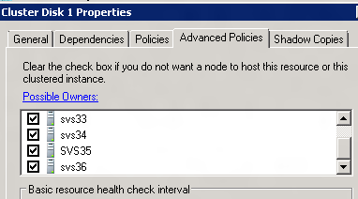 | Controleer of alle Possible Owners aangevinkt zijn
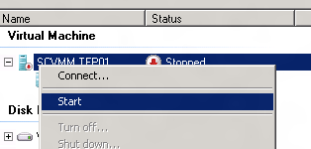 | Start de VM
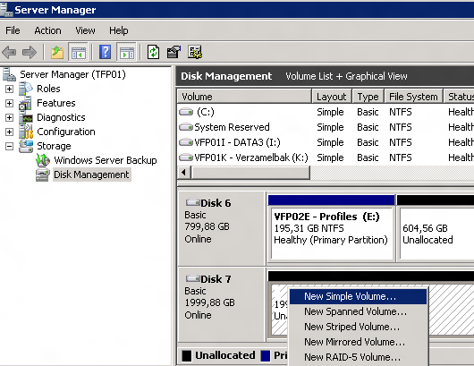 | Open de VM (RDP)  Open Disk Management  Maak een Simple Volume
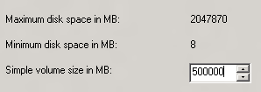 | NB: Max size /4!!!!
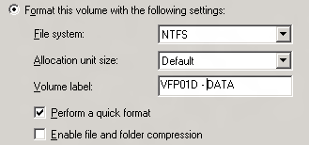 | Label het volume gelijk aan de naam in HP Command View
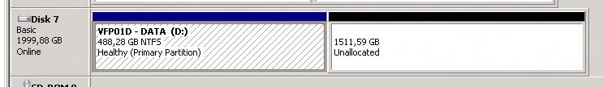 | Klaar.

- IP Configuratie

#SVS32
netsh.exe int ipv4 set address name="Management" static 172.17.5.51 255.255.255.0 172.17.5.254
netsh int ipv4 set dnsserver "Management" static 172.17.10.1 primary
netsh int ipv4 add dnsserver "Management" 172.17.10.101 index=2
netsh.exe int ipv4 set address name="Cluster" static 172.17.111.1 255.255.255.0
netsh.exe int ipv4 set address name="CSV" static 172.17.112.1 255.255.255.0
netsh.exe int ipv4 set address name="Live Migration" static 172.17.113.1 255.255.255.0
netsh.exe int ipv4 set address name="Backup" static 172.17.30.21 255.255.255.0

#SVS32
netsh.exe int ipv4 set address name="Management" static 172.17.5.53 255.255.255.0 172.17.5.254
netsh int ipv4 set dnsserver "Management" static 172.17.10.1 primary
netsh int ipv4 add dnsserver "Management" 172.17.10.101 index=2
netsh.exe int ipv4 set address name="Cluster" static 172.17.111.2 255.255.255.0
netsh.exe int ipv4 set address name="CSV" static 172.17.112.2 255.255.255.0
netsh.exe int ipv4 set address name="Live Migration" static 172.17.113.2 255.255.255.0
netsh.exe int ipv4 set address name="Backup" static 172.17.30.22 255.255.255.0

#SVS33
netsh.exe int ipv4 set address name="Management" static 172.17.5.55 255.255.255.0 172.17.5.254
netsh int ipv4 set dnsserver "Management" static 172.17.10.1 primary
netsh int ipv4 add dnsserver "Management" 172.17.10.101 index=2
netsh.exe int ipv4 set address name="Cluster" static 172.17.111.3 255.255.255.0
netsh.exe int ipv4 set address name="CSV" static 172.17.112.3 255.255.255.0
netsh.exe int ipv4 set address name="Live Migration" static 172.17.113.3 255.255.255.0
netsh.exe int ipv4 set address name="Backup" static 172.17.30.23 255.255.255.0

#SVS34
netsh.exe int ipv4 set address name="Management" static 172.17.5.57 255.255.255.0 172.17.5.254
netsh int ipv4 set dnsserver "Management" static 172.17.10.1 primary
netsh int ipv4 add dnsserver "Management" 172.17.10.101 index=2
netsh.exe int ipv4 set address name="Cluster" static 172.17.111.4 255.255.255.0
netsh.exe int ipv4 set address name="CSV" static 172.17.112.4 255.255.255.0
netsh.exe int ipv4 set address name="Live Migration" static 172.17.113.4 255.255.255.0
netsh.exe int ipv4 set address name="Backup" static 172.17.30.24 255.255.255.0

#SVS35
netsh.exe int ipv4 set address name="Management" static 172.17.5.59 255.255.255.0 172.17.5.254
netsh int ipv4 set dnsserver "Management" static 172.17.10.1 primary
netsh int ipv4 add dnsserver "Management" 172.17.10.101 index=2
netsh.exe int ipv4 set address name="Cluster" static 172.17.111.5 255.255.255.0
netsh.exe int ipv4 set address name="CSV" static 172.17.112.5 255.255.255.0
netsh.exe int ipv4 set address name="Live Migration" static 172.17.113.5 255.255.255.0
netsh.exe int ipv4 set address name="Backup" static 172.17.30.25 255.255.255.0

#SVS36
netsh.exe int ipv4 set address name="Management" static 172.17.5.61 255.255.255.0 172.17.5.254
netsh int ipv4 set dnsserver "Management" static 172.17.10.1 primary
netsh int ipv4 add dnsserver "Management" 172.17.10.101 index=2
netsh.exe int ipv4 set address name="Cluster" static 172.17.111.6 255.255.255.0
netsh.exe int ipv4 set address name="CSV" static 172.17.112.6 255.255.255.0
netsh.exe int ipv4 set address name="Live Migration" static 172.17.113.6 255.255.255.0
netsh.exe int ipv4 set address name="Backup" static 172.17.30.26 255.255.255.0

- Netwerkconfiguratie

( Get-ClusterNetwork "Management" ).AutoMetric = False
( Get-ClusterNetwork "Management" ).Metric = 300
( Get-ClusterNetwork "CSV" ).AutoMetric = False
( Get-ClusterNetwork "CSV" ).Metric = 300
( Get-ClusterNetwork "CSV" ).AutoMetric = False
( Get-ClusterNetwork "CSV" ).Metric = 300
( Get-ClusterNetwork "CSV" ).AutoMetric = False
( Get-ClusterNetwork "CSV" ).Metric = 300

# Dennis van den Akker
# d.vandenakker@icento.nl
# Icento B.V.
# Version 2.0
# Notes: This script will rename the network adaptor connection based on physical hardware order. It wil also set the binding order, metric, DNS registration and DNS suffic.
# There are known issues, contact the author!

$blDebug = $True
$blModify = $True

# Create variables that are used for the optimization
$oDevs = @{}
$oVMDevs = @{}
$oIPv4 = @{}
$oIPv6 = @{}
$iVMDevs = 0
$iAdap = 1

# Host management adapter
$iManNic = 6 # Management NIC, this one is used for managing the operating system and has the register in DNS enabled
$sManDnsSuffix = "vnog.intra"

# Overview table
# Function Binding order Metric
# Management 1 100-199
# iSCSI 2 200-299
# Live Migration 3 400-499
# Cluster Shared Volume 4 300-399
# Other networks 5 1.000-4.999
# Cluster heartbeat 6 500-599
# Virtual switches 7 5.000-9.999

# Physical network order and network connection name
$oAdaps = @{}
$oAdaps.Add(1,"Cluster")
$oAdaps.Add(2,"CSV")
$oAdaps.Add(3,"Live Migration")
$oAdaps.Add(4,"LAN Trunk 1")
$oAdaps.Add(5,"Backup")
$oAdaps.Add(6,"Management")
$oAdaps.Add(7,"DMZ Trunk")
$oAdaps.Add(8,"LAN Trunk 2")

# Network adapter order
# See table Function <hardware order>, table Binding order
$oOrder = @{}
$oOrder.Add(1,6)
$oOrder.Add(2,4)
$oOrder.Add(3,3)
$oOrder.Add(4,7)
$oOrder.Add(5,5)
$oOrder.Add(6,1)
$oOrder.Add(7,7)
$oOrder.Add(8,7)

# Hardware order and metric numbers
# See table Function <hardware order>, table Metric number
$oMetrics = @{}
$oMetrics.Add(1,500)
$oMetrics.Add(2,300)
$oMetrics.Add(3,400)
$oMetrics.Add(4,5000)
$oMetrics.Add(5,4000)
$oMetrics.Add(6,100)
$oMetrics.Add(7,5000)
$oMetrics.Add(8,5000)

$oAdapters = Get-WMIObject Win32_PNPSignedDriver | where { $_.DeviceClass -eq "NET" -and $_.HardWareID -like "*PCI*"}
#$oAdapters = Get-WMIObject Win32_PNPSignedDriver | where { $_.DeviceClass -eq "NET" -and ($($_.HardwareID.ToString()).StartsWith("PCI") -or $($_.HardwareID.ToString()).StartsWith("VMBUS"))}

Write-Host "Specified connections for $($oAdaps.Count) adapters"
Write-Host "Found $($oAdapters.Count) network adapters"
Write-Host

if ($oAdaps.Count -eq $oAdapters.Count) {
"Run the script"
} else {
"Other number of defined network interfaces"
break;
}

foreach ($oAdap in $oAdapters) {
if ($oAdap.Location.Length -gt 0) {
$s = $oAdap.Location.Substring(8,($oAdap.Location.IndexOf(',')-8))
#$oAdap.Location.Substring($oAdap.Location.Length-1,1)
$i = ([int]$s*10)+([int]$oAdap.Location.Substring($oAdap.Location.Length-1,1))
$oDevs.Add($i,$($oAdap.DeviceID))
} else {
$oVMDevs.Add($iVMDevs,$oAdap.DeviceID)
$iVMDevs++
}
}

function addZero($iInput){
return "{0:D4}" -f [int]$iInput
}

$oDevNew = $oDevs.GetEnumerator() | Sort-Object Name
if ($oDevNew -ne $Null) {
foreach ($oItem in $oDevNew) {
$oDrv = Get-WMIObject Win32_PNPSignedDriver | where { $_.DeviceClass -eq "NET" -and $_.HardWareID -like "*PCI*" -and $_.DeviceID -eq $($oItem.Value)}
$oNet = Get-WMIObject Win32_NetworkAdapter | where { $_.PNPDeviceID -eq $($oItem.Value)}

Write-Host "Interface $iAdap [$($oNet.NetConnectionID)]"
if ($blDebug) {
Write-Host 'Adapter Name :' $oNet.NetConnectionID
Write-Host 'PCI BUS :' $oDrv.Location
Write-Host 'MAC Address :' $oNet.MACAddress
Write-Host 'GUID :' $oNet.GUID
Write-Host 'Device ID:' $oNet.DeviceID
}

if ($oAdaps[$iAdap].ToString() -cne $oNet.NetConnectionID.ToString()) {
Write-Host "Current name [$($oNet.NetConnectionID)] change to [$($oAdaps[$iAdap])]" -ForegroundColor Yellow
# if ($blModify) {
$oNet.NetConnectionID = $oAdaps[$iAdap]
$oNet.psbase.Put()
#$oNet.psbase.Put("NetConnectionID",$oAdaps[$iAdap]) # | Out-Null
# }
Write-Host 'GUID :' $oNet.GUID
}
$oAdapConfigs = Get-WMIObject -Query "select * from Win32_NetworkAdapterConfiguration where Caption ='$($oNet.Caption)'"
foreach ($oAdapConfig in $oAdapConfigs) {
if ($oAdapConfig.IPConnectionMetric -ne $oMetrics[$iAdap]) {
if ($oAdapConfig.IPEnabled -eq $True) {
Write-Host "Changing connection metric from $($oAdapConfig.IPConnectionMetric) to $($oMetrics[$iAdap])..." -ForegroundColor Yellow -NoNewLine

if ($blModify) {
$oRet = $oAdapConfig.SetIPConnectionMetric($($oMetrics[$iAdap]))
if ($oRet.ReturnValue -eq 0) {
Write-Host "completed" -ForegroundColor Green
} else {
Write-Host "failed [$($oRet.ReturnValue)]" -ForegroundColor Red
}
}
}

if ($blModify) {
if ($iAdap -eq $iManNic) {
$oAdapConfig.SetDynamicDNSRegistration($True,$False) | Out-Null
$oAdapConfig.SetDNSDomain($sManDnsSuffix) | Out-Null
} else {
$oAdapConfig.SetDynamicDNSRegistration($False,$False) | Out-Null
}
} else {
Write-Host
}
}

if ($blModify) {
if ($iAdap -eq $iManNic) {
$oAdapConfig.SetDynamicDNSRegistration($True,$False) | Out-Null
$oAdapConfig.SetDNSDomain($sManDnsSuffix) | Out-Null
} else {
$oAdapConfig.SetDynamicDNSRegistration($False,$False) | Out-Null
}
}
}

#if ($oNet.NetConnectionID -match "iscsi") {
if ($oAdaps[$iAdap] -match "iscsi") {
Write-Host "iSCSI connection [$($oNet.NetConnectionID)]"
Write-Host " Unbinding from IPv6"
# Unbind TCP IPv6 from adapter
$sRegProp = $(Get-ItemProperty -Path "HKLM:\SYSTEM\CurrentControlSet\Control\Class\{4D36E972-E325-11CE-BFC1-08002BE10318}\$(addZero($oNet.DeviceID))\Linkage").UpperBind | Select-String -Pattern "Tcpip6" -NotMatch -SimpleMatch
Set-ItemProperty -Path "HKLM:\SYSTEM\CurrentControlSet\Control\Class\{4D36E972-E325-11CE-BFC1-08002BE10318}\$(addZero($oNet.DeviceID))\Linkage" -Name "UpperBind" -Type MultiString -Value $sRegProp
}
$oIPv4.Add($iAdap,$oNet.GUID)
$oIPv6.Add($iAdap,$oNet.GUID)

$iAdap++
Write-Host
}
}

# Bind IPv4
$oVal = @{}
$i=0
foreach ($oItem in ($oOrder.GetEnumerator() | Sort-Object -Property Name)) {
$oVal.Add($i,"\Device\$($oIPv4[$oItem.Value])")
$i++
}
$oArrBindIPv4 = ($oVal.GetEnumerator() | Sort-Object -Property Name) | Select -ExpandProperty Value

# Export IPv4
$oVal = @{}
$i=0
foreach ($oItem in ($oOrder.GetEnumerator() | Sort-Object -Property Name)) {
$oVal.Add($i,"\Device\Tcpip_$($oIPv4[$oItem.Value])")
$i++
}
$oArrExportIPv4 = ($oVal.GetEnumerator() | Sort-Object -Property Name) | Select -ExpandProperty Value

# Route IPv4
$oVal = @{}
$i=0
foreach ($oItem in ($oOrder.GetEnumerator() | Sort-Object -Property Name)) {
$oVal.Add($i,"""$($oIPv4[$oItem.Value])""")
$i++
}
$oArrRouteIPv4 = ($oVal.GetEnumerator() | Sort-Object -Property Name) | Select -ExpandProperty Value

# Bind IPv6
$oVal = @{}
$i=0
$iSCSI=0
foreach ($oItem in ($oOrder.GetEnumerator() | Sort-Object -Property Name)) {
if (($($oAdaps[$oItem.Name]) -match "iscsi") -eq $False) {
$oVal.Add($iSCSI,"""$($oIPv6[$oItem.Value])""")
$iSCSI++
}
$i++
}
$oArrBindIPv6 = ($oVal.GetEnumerator() | Sort-Object -Property Name) | Select -ExpandProperty Value

# Export IPv6
$oVal = @{}
$i=0
$iSCSI=0
foreach ($oItem in ($oOrder.GetEnumerator() | Sort-Object -Property Name)) {
if (($($oAdaps[$oItem.Name]) -match "iscsi") -eq $False) {
$oVal.Add($i,"\Device\Tcpip_$($oIPv6[$oItem.Value])")
$iSCSI++
}
$i++
}
$oArrExportIPv6 = ($oVal.GetEnumerator() | Sort-Object -Property Name) | Select -ExpandProperty Value

# Route IPv6
$oVal = @{}
$i=0
$iSCSI=0
foreach ($oItem in ($oOrder.GetEnumerator() | Sort-Object -Property Name)) {
if (($($oAdaps[$oItem.Name]) -match "iscsi") -eq $False) {
$oVal.Add($i,"""$($oIPv6[$oItem.Value])""")
$iSCSI++
}
$i++
}
$oArrRouteIPv6 = ($oVal.GetEnumerator() | Sort-Object -Property Name) | Select -ExpandProperty Value

Write-Host "Bind IPv4"
$oArrBindIPv4
Write-Host "Export IPv4"
$oArrExportIPv4
Write-Host "Route IPv4"
$oArrRouteIPv4

Write-Host ""
Write-Host "Bind IPv6"
$oArrBindIPv6
Write-Host "Export IPv6"
$oArrExportIPv6
Write-Host "Route IPv6"
$oArrRouteIPv6

if ($blModify) {
# IPv4
Set-ItemProperty -Path 'HKLM:\SYSTEM\CurrentControlSet\services\Tcpip\Linkage' -Name 'Bind' -Type MultiString -Value $oArrBindIPv4
Set-ItemProperty -Path 'HKLM:\SYSTEM\CurrentControlSet\services\Tcpip\Linkage' -Name 'Export' -Type MultiString -Value $oArrExportIPv4
Set-ItemProperty -Path 'HKLM:\SYSTEM\CurrentControlSet\services\Tcpip\Linkage' -Name 'Route' -Type MultiString -Value $oArrRouteIPv4
# IPv6
Set-ItemProperty -Path 'HKLM:\SYSTEM\CurrentControlSet\services\Tcpip6\Linkage' -Name 'Bind' -Type MultiString -Value $oArrBindIPv6
Set-ItemProperty -Path 'HKLM:\SYSTEM\CurrentControlSet\services\Tcpip6\Linkage' -Name 'Export' -Type MultiString -Value $oArrExportIPv6
Set-ItemProperty -Path 'HKLM:\SYSTEM\CurrentControlSet\services\Tcpip6\Linkage' -Name 'Route' -Type MultiString -Value $oArrRouteIPv6
}

- AntiAffinity

Import-Module FailoverClusters
$oAntiAffinity = New-Object System.Collections.Specialized.StringCollection
$oAntiAffinity.Add("Citrix XenDesktop")
(Get-ClusterGroup -Cluster svs30 -Name "SCVMM VXD01 Resources").AntiAffinityClassNames =$oAntiAffinity
(Get-ClusterGroup -Cluster svs30 -Name "SCVMM VXD02 Resources").AntiAffinityClassNames =$oAntiAffinity

$oAntiAffinity = New-Object System.Collections.Specialized.StringCollection
$oAntiAffinity.Add("Citrix Web Interface")
(Get-ClusterGroup -Cluster svs30 -Name "SCVMM VWI01 Resources").AntiAffinityClassNames =$oAntiAffinity
(Get-ClusterGroup -Cluster svs30 -Name "SCVMM VWI02 Resources").AntiAffinityClassNames =$oAntiAffinity

Overzicht van hosts welke niet op dezelfde fysieke server hoort te draaien:

Name AntiAffinityClassNames
---- ----------------------
SCVMM VEX02 Resources {Exchange 2010}
SCVMM VEX03 Resources {Exchange 2010}
SCVMM VWI01 Resources {Citrix Web Interface}
SCVMM VWI02 Resources {Citrix Web Interface}
SCVMM VXD01 Resources {Citrix XenDesktop}
SCVMM VXD02 Resources {Citrix XenDesktop}

