

SCDPM 2012
Systeem Documentatie



.datum | 2 oktober 2012
.op verzoek van | VNOG
.versie | 1.0
.documentreferentie | SD20120731JSl(Inrichting SCDPM 2012)v1.0.docx

Disclaimer

Alle rechten voorbehouden. U ontvangt dit document onder de uitdrukkelijke voorwaarde dat u dit document vertrouwelijk zal behandelen en dat, indien u niet wenst in te gaan op dit document, van de inhoud geen gebruik zal maken zonder voorafgaande schriftelijke toestemming van PeopleWare ICT Solutions. Tevens is het niet toegestaan dit document op enigerlei wijze aan derden ter beschikking te stellen zonder voorafgaande schriftelijke toestemming van PeopleWare ICT Solutions. PeopleWare ICT Solutions behoudt zich alle rechten voor ter zake auteursrecht rustende op dit document. Alle genoemde handelsmerken in dit document zijn eigendom van de rechthebbenden.

Dit document is gebaseerd op informatie die is verstrekt door u en PeopleWare ICT Solutions kan niet garanderen dat deze informatie correct en/of compleet is. Omdat PeopleWare ICT Solutions de veranderingen in techniek en de wijzigingen in de computer- en netwerkomgevingen van klanten volgt, dient dit document niet te worden opgevat als een verbintenis of toezegging van PeopleWare ICT Solutions.

© 2012, PeopleWare ICT Solutions

Documentenbeheer
Versiebeheer

Versie | Auteur |  | Aanpassingen |  |  | Datum
0.1 | Johan Sleeuwenhoek |  | Eerste versie. |  |  | 24-07-2012
1.0 | Johan Sleeuwenhoek |  | Review |  |  | 02-10-2012
Document review & distributie

Naam reviewer |  | Organisatie |  | E-mail adres |  | Review datum
Documentgoedkeuring

Naam |  | Handtekening |  |  | Datum

Inhoudsopgave

Hoofdstuk 1 Parameters 5
1.1 SCDPM Server 5
1.2 Patches en hotfixes 5
1.3 Service Accounts 5
Hoofdstuk 2 SCDPM 2012 6
2.1 Installatie 6
2.2 Installatie Agents 8
2.3 Installatie Protection Group 9
2.4 Configuratie 10
Hoofdstuk 3 Backupschema 12
3.1 Short-term 12
3.2 Long-term 12
3.3 Tape Optimization (tape co-location) 12
Hoofdstuk 4 CSV Backup 13
4.1 Software Provider 13
Hoofdstuk 5 Installatie DPM Agent 16
Bijlage 1 AddNewClusteredVM.ps1 17

- Parameters

Zie Implementatie Specificaties.

- SCDPM Server

Functie | Backup Server
Naam | SBA01.vnog.intra
Type | Fysiek
CPU | Quadcore CPU
Memory | 18 GB
Rollen | Hyper-V
Diskindeling | C: - 80GB voor OS en APPS (Page file: 43 GB)  D: - 10GB voor SCDPM 2012  E: - 20 GB voor SCDPM DB  F: - 5 GB voor SCDPM Log  Storage Pool Replica volume – 7200 GB  Storage Pool Recovery volume – 3454 GB
Network | 4 Gbps (trunk 4 x 1 Gbps)
IP | 172.17.10.6
Subnetmask | 255.255.255.0
Backup NIC | 172.17.30.6
Gateway | 172.17.10.254
DNS | 172.17.10.1  172.17.10.101

- Patches en hotfixes

Patch | Omschrijving
KB2494162 | The Cluster service stops unexpectedly on a Windows Server 2008 R2 failover cluster node when you perform multiple backup operations in parallel on a cluster shared volume
KB2521348 | A virtual machine online backup fails in Windows Server 2008 R2 when the SAN policy is set to "Offline All"
KB2627052 | Computer randomly stops responding after you use the VSS software provider in Windows Server 2008 R2 or in Windows 7
KB2632149 | "fvevol!FveFilterDeviceControl+1d0" Stop error when you create a VSS snapshot backup in Windows Server 2008 R2 SP1
KB2661530 | The whole backup operation fails if one out of several virtual machines on a Hyper-V server cannot be backed up in Windows Server 2008 R2
KB2661794 | MPIO does not remove a disk that is on a failed path in Windows Server 2008 R2
KB2647841 | Various issues after you restore a system state backup that is saved by using VSS if the "ImagePath" value for a service contains a forward slash (/) in Windows Vista, in Windows 7, in Windows Server 2008 or in Windows Server 2008 R2
KB2666703 | You cannot restore a virtual machine that has a semicolon in its name or in its directory path on a Windows Server 2008 R2 SP1-based server
KB2678241 | DFS Replication service crashes when you perform a backup operation on a computer that is running Windows Server 2008 R2
KB2692929 | "0x80041001" error when the Win32_Environment WMI class is queried by multiple requestors in Windows 7 or in Windows Server 2008 R2
KB2699780 | Memory leak in the Remote Registry service on a computer that is running Windows 7 or Windows Server 2008 R2
KB2708549 | Stop error when you create a VSS snapshot backup in Windows 7 SP1 or in Windows Server 2008 R2 SP1: "fvevol!FveFilterDeviceControl+1d0"
KB2708811 | Data corruption occurs when a sparse file undergoes random write stress in Windows 7 or in Windows Server 2008 R2
KB2718576 | MPIO disk is removed unexpectedly when a PR_IN command fails in a Windows Server 2008 R2 environment
KB2722392 | "0x000000F4" Stop error when you run the Device Fundamental tests in Windows 7 or in Windows Server 2008 R2

- Service Accounts

Account

- SCDPM 2012

- Installatie

Scherm | Aktie
dism.exe /Online /Enable-Feature /FeatureName:Microsoft-Hyper-V-Management-Clients /FeatureName:FailoverCluster-AdminPak /FeatureName:Microsoft-Hyper-V /FeatureName:MultipathIo | Installeer Features
mpclaim -r -i -a | Enable MPIO
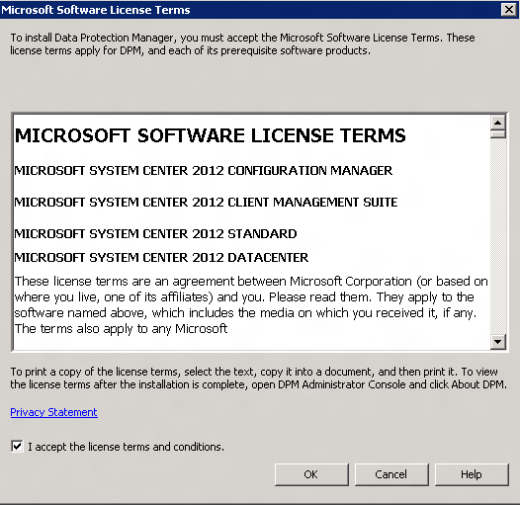 | Start setup.exe
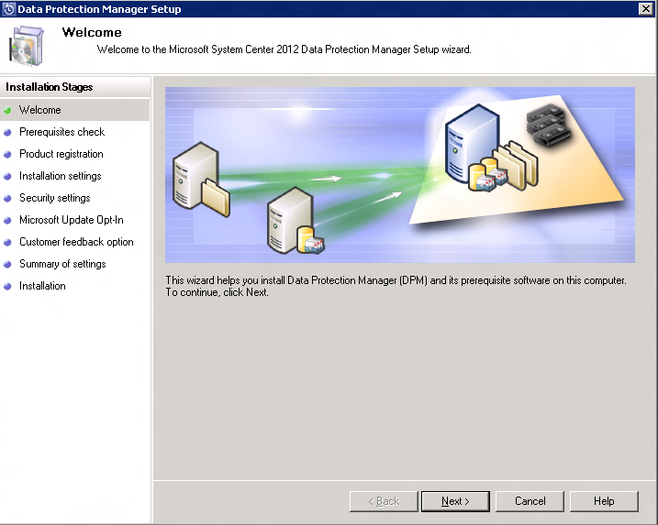 | Next
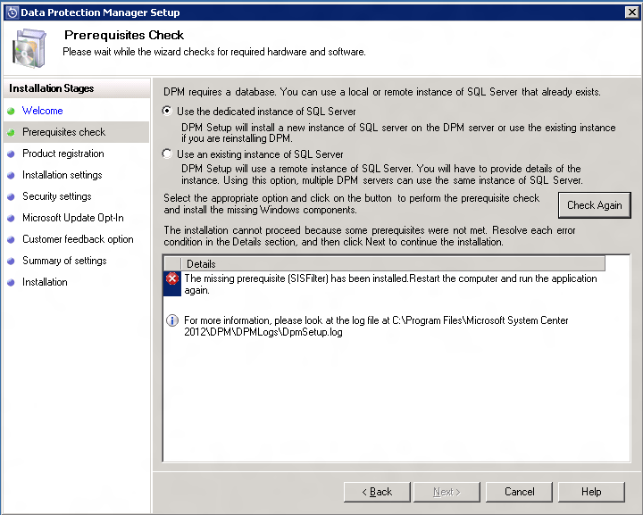 | Use the dedicated instanse of SQL Server  Check and Install  Restart  Run setup again  Next
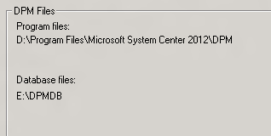 | Next
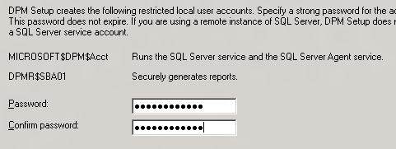 | Enter Password
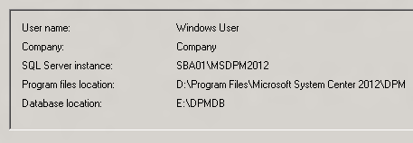 | Install
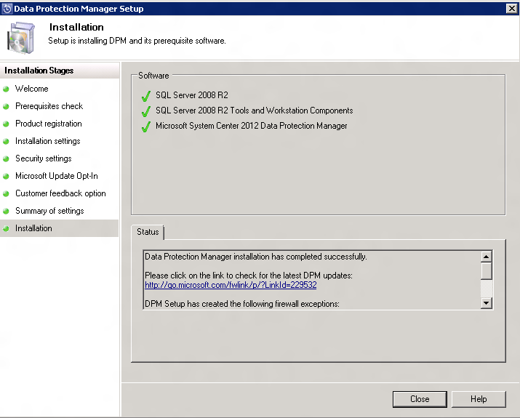 | Close

- Installatie Agents

Scherm | Aktie
@ECHO OFF  NET USE Y: "\\sba01\D$\Program Files\Microsoft System Center 2012\DPM\DPM\ProtectionAgents\RA\4.0.1908.0"  Y:  cd amd64  DPMAgentInstaller_x64.exe sba01.vnog.intra  c:  net use y: /del | Draai het volgende script op de Agent.
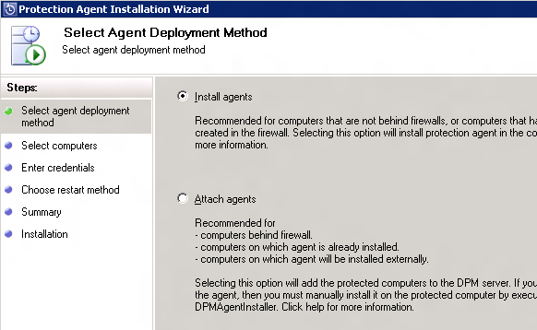 | Installeer Agents  Management  Agents  Attach
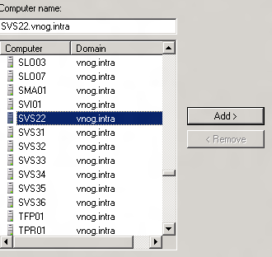 | Selecteer Server(s)  Add  Next
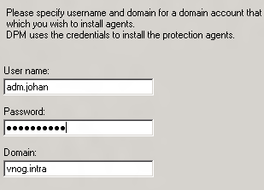 | Admin account (alleen voor installatie)
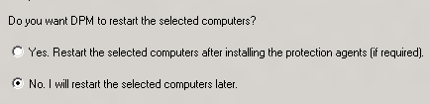 | No

- Installatie Protection Group

Scherm | Aktie
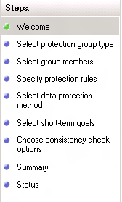 | Protection  New
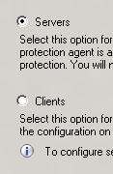 | Servers  Next
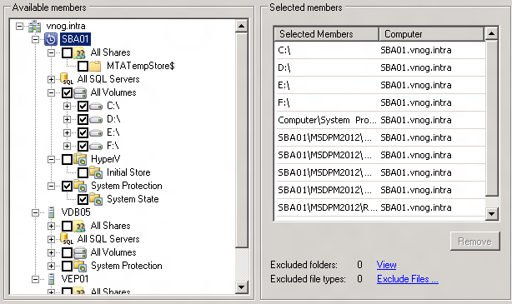 | Voeg members toe
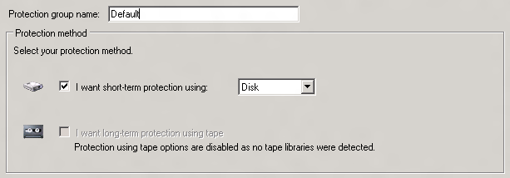 | Naam: Default  NB: DPM DB apart Backuppen!!
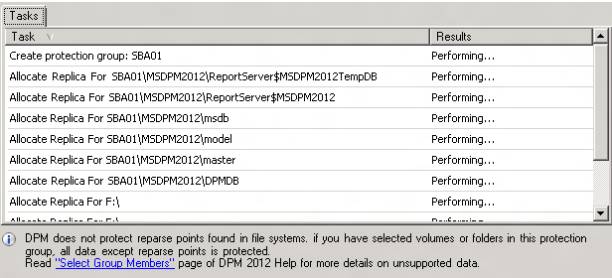

- Configuratie

Scherm | Aktie
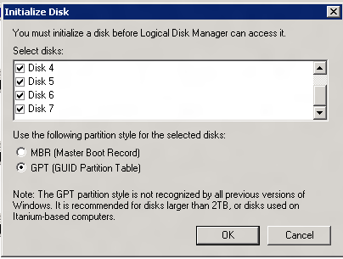 | Initialize Disks  GPT  OK
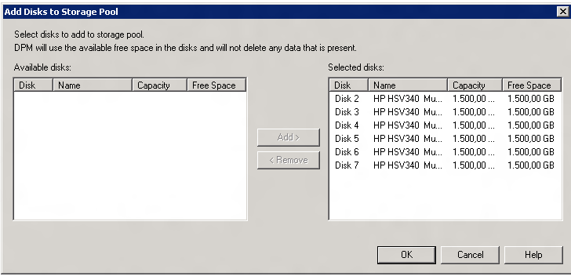 | Start DPM GUI  Management  Disks  Add
Add-DPMBackupNetworkAddress -DpmServername sba01.vnog.intra -Address 172.17.30.0/24 -SequenceNumber 1  Add-DPMBackupNetworkAddress -DpmServername sba01.vnog.intra -Address 172.17.10.0/24 -SequenceNumber 2 | Voeg het Backup Network toe.  Alternatief via het .10 netwerk
netsh int tcp set global chimney=disabled | Disable Chimney Offloading
172.17.30.21 svs31 svs31.vnog.intra  172.17.30.22 svs32 svs32.vnog.intra  172.17.30.23 svs33 svs33.vnog.intra  172.17.30.24 svs34 svs34.vnog.intra  172.17.30.25 svs35 svs35.vnog.intra  172.17.30.26 svs36 svs36.vnog.intra | Voeg de Backup IP Adressen toe aan de hosts file van de SBA01
172.17.30.6 sba01 sba01.vnog.intra | Voer het Backup IP toe aan de hosts file van de te backuppen servers.
AddNewClusteredVM.cmd  AddNewClusteredVM.ps1 Zie Bijlage 1 | Schedule AddNewClusteredVM.cmd  Elke dag om 18:00
  @ECHO OFF
  C:\Windows\system32\windowspowershell\v1.0\powershell.exe -command 'C:\SCRIPTS\AddNewCLusteredVM.ps1

- Backupschema

- Short-term

Account | Retention Range | Synchronization Frequency | File recovery points | Express Full Backup
Fileservers | 14 dagen | Just before a recovery point | - | 20:00 Every day
Exchange | 14 dagen | Elke 4 uur | - | 20:00 Every day
SQL | 14 dagen | Just before a recovery point | - | 20:00 Every day
Servers | 14 dagen | Just before a recovery point | 22:00 Every day | 22:00 Every day
Hyper-V | 7 dagen | - | - | 22:00 Zaterdag

- Long-term

Account | Recovery goals | Backup Schedule | Tape Label
Fileservers | Elke dag voor 1 week  Elke week voor 4 weken  Elke maand voor 12 maanden | 22:00 behalve vr, za en zo  22:00 vrijdag  22:00 Last vrijdag | Dag  Week  Maand
Exchange | Elke dag voor 1 week  Elke week voor 4 weken  Elke maand voor 12 maanden | 22:00 behalve vr, za en zo  22:00 vrijdag  22:00 Last vrijdag | Dag  Week  Maand
SQL | Elke dag voor 1 week  Elke week voor 4 weken  Elke maand voor 12 maanden | 22:00 behalve vr, za en zo  22:00 vrijdag  22:00 Last vrijdag | Dag  Week  Maand
Servers | Elke week voor 4 weken  Elke maand voor 12 maanden | 2:00 Zaterdag  2:00 Last zaterdag | Week  Maand
Hyper-V | Elke week voor 4 weken  Elke maand voor 12 maanden | 2:00 Zondag  2:00 Last zondag | Week  Maand

- Tape Optimization (tape co-location)

Parameter | Waarde
Naam | Backup
Protection Groups | Fileservers  Exchange  SQL
Don’t allow backup of different retention periods to co-locate on the same tape | On
Advanced: Write period | 0 days
Advanced: Expiry tolerance | 0 days

- CSV Backup

- Software Provider

Edit de volgende registry key op de DPM server:
reg add "HKLM\Software\Microsoft\Microsoft Data Protection Manager\2.0\Configuration\MaxAllowedParallelBackups" /v "Microsoft Hyper-V" /d 1 /t REG_DWORD /f

Edit de volgende registry key op de Hyper-V nodes
reg add "\\SVS31\HKLM\Software\Microsoft\Microsoft Data Protection Manager\Agent\UseSystemSoftwareProvider" /ve
reg add "\\SVS32\HKLM\Software\Microsoft\Microsoft Data Protection Manager\Agent\UseSystemSoftwareProvider" /ve
reg add "\\SVS33\HKLM\Software\Microsoft\Microsoft Data Protection Manager\Agent\UseSystemSoftwareProvider" /ve
reg add "\\SVS34\HKLM\Software\Microsoft\Microsoft Data Protection Manager\Agent\UseSystemSoftwareProvider" /ve
reg add "\\SVS35\HKLM\Software\Microsoft\Microsoft Data Protection Manager\Agent\UseSystemSoftwareProvider" /ve
reg add "\\SVS36\HKLM\Software\Microsoft\Microsoft Data Protection Manager\Agent\UseSystemSoftwareProvider" /ve

Herstart DPMRA op de Hyper-V nodes
SC \\SVS31 stop DPMRA
SC \\SVS32 stop DPMRA
SC \\SVS33 stop DPMRA
SC \\SVS34 stop DPMRA
SC \\SVS35 stop DPMRA
SC \\SVS36 stop DPMRA

SC \\SVS31 start DPMRA
SC \\SVS32 start DPMRA
SC \\SVS33 start DPMRA
SC \\SVS34 start DPMRA
SC \\SVS35 start DPMRA
SC \\SVS36 start DPMRA

Run DSConfig.ps1 op een clusternode
# DSConfig.ps1

$infoText = "This script will generate the DatasourceGroups.xml file in the current path. Once this file is created merge it with the same file name under %programfiles%\Microsoft DPM\DPM\Config directory on the DPM server. Read the documentation for more details."
echo $infoText

$header = "<?xml version=`"1.0`" encoding=`"utf-16`"?> `n <DatasourceGroup xmlns:xsi=`"http://www.w3.org/2001/XMLSchema-instance`" xmlns:xsd=`"http://www.w3.org/2001/XMLSchema`" xmlns=`"http://schemas.microsoft.com/2003/dls/GroupDatasourceByDisk.xsd`">"
$footer = "</DatasourceGroup>"

import-module -name FailoverClusters

$dir = [guid]::NewGuid()
md $dir

$cluster = get-Cluster
$FQDN = $cluster.Name + "." + $cluster.Domain
$res = get-clusterresource | where-object { $_.ResourceType.Name -eq "Virtual Machine Configuration"}
foreach ($r in $res)
{
$VmObj = Get-ClusterParameter -inputobject $r | where {$_.Name -eq "VmStoreRootPath"} # Identifies the CSV volume on which the VM is hosted.
$VmName = Get-ClusterParameter -inputobject $r | where {$_.Name -eq "VmId"}
$vol = $vmobj.Value.Split("\")[2] # $vol will return to us the Volume<number> of the CSV on which the VM resides.
$line = "<Datasource DatasourceName=`"" + $VmName.Value +"`"" + " ProtectedServerName=`"" + $r.OwnerGroup.Name + "."+ $FQDN +"`"" + " WriterId=`"66841cd4-6ded-4f4b-8f17-fd23f8ddc3de`" />"
echo $line >> $dir\$vol # File VolumeX will contain entries for all VMs hosted on CSV VolumeX
}

echo $header > DataSourceGroups.xml
$filelist = dir $dir\*
$GroupEndString = "</Group>"
foreach ($file in $filelist)
{
$GroupBeginString = "<Group GroupName=`"" + $file.Name + "-" + $FQDN + "`">" # Group name is kept VolumeX itself
echo $GroupBeginString >> DataSourceGroups.xml
type $file >> DataSourceGroups.xml # Consolidating groups pertaining to all the volumes.
echo $GroupEndString >> DataSourceGroups.xml
}

Remove-Item -Force -Recurse $dir

echo $footer >> DataSourceGroups.xml

Kopieer DataSourceGroups.xml naar D:\Program Files\Microsoft System Center 2012\DPM\DPM\Config op de DPM server.

- Installatie DPM Agent

Start de volgende batch
- AddNewClusteredVM.ps1

Import-Module DataProtectionManager

# AddNewClusteredVM.ps1
# This script is expected to work with DPM 2010 Beta

# 1. Parameters supplied to the script
#param([string] $ProductionCluster = "", [string] $PGName = "")

$Productioncluster = "svs30.vnog.intra"
$PGName = "Hyper-V"

# 2. Failures are registered in Applocation events in the DPM server.
trap [Exception] {
$log = Get-EventLog -List | Where-Object { $_.Log -eq "Application" }
$log.Source = "AddNewClusteredVM"
$log.WriteEntry("TRAPPED: $error[0]", [system.Diagnostics.EventLogEntryType]::Error,9911)
$Error[0] #show on console
exit
}

# 3. Prompt for missing parameters
#if(!$ProductionCluster)
#{
# $Productioncluster = read-host "Enter the cluster FQDN "
#}
#if(!$PGName)
#{
# $PGName = read-host "Enter the name of your existing Hyper-V protection group "
#}

$dpmservername = &"hostname"
connect-dpmserver $dpmservername

# Do not modify this line
$tape = "Short-term using tape"

# Hyper-V Writer guid
$guid = "66841cd4-6ded-4f4b-8f17-fd23f8ddc3de"

# 4. Search for the protection group name passed as input and exit if it was not found
$PGList = @(Get-ProtectionGroup $dpmservername)
$PG = $PGlist | where { $_.FriendlyName -eq $PGName}
if (!$PG) { Throw "Specified protection group [$PGname] is not found!" }

# 5. Obtain the list of protected clusters on this DPM server
$Cluster = Get-ProductionCLuster $dpmservername | ? { $_.ClusterName -eq $ProductionCluster}
if (!$Cluster) { Throw "Specified cluster name [$ProductionCluster] is not found!" }

$RGList = @()
$joblist = @()
$global:DSlist = @()

# 6. Run inquiry on cluster to get list of available resource groups
write-host "Running Inquiry on" $Cluster.clusterName
$RGlist = Get-ProductionVirtualName $Cluster

# 7. Need to run inquiry on each resource group
foreach ($RG in $RGlist)
{
write-host "Running Inquiry on" $RG.NetBiosName
# 7.1 Inquiry is run in parallel and the event mechanism is used to signal completion of inquiry.
# 'DataSourceDetectionEvent' event signals the completion of inquiry. and the data sources obtained are added to the global variable
$joblist += register-objectevent -inputobject $RG -Eventname DatasourceDetectionEvent -Action {$global:DSlist += $($Event.SourceEventArgs.ProtectableObjects)}

# 7.2 Run inquiry
Get-Datasource -ProductionServer $RG -Inquire -Async
}

# 8. Scan through each job created in the previous loop
foreach ($job in $joblist)
{
# 8.1 Waiting for the job to run
while ($job.State -eq "NotStarted")
{
write-host "Waiting for inquiry to complete" $global:DSlist.count "item(s) obtained..."
sleep 1
}
}
# 8.2 Inquiry complete on all resource groups

write-host "Inquiry listed" $global:DSlist.count "item(s)..."

# 9. If object is a data source and of type Hyper-V and is currently not protected add to list of unprotected VMs
$unprotectedDSList = @(($global:DSList) | ? {$($_.Type.IsDatasource) -and ($($_.Type.Id) -match $guid) -and ! $($_.Protected)})

# 10. Exit if there are no unprotected VMs
if ($unprotectedDSList.count -lt 1)
{
write-host "No new datasources found!"
exit 1
}

# 11. Obtain a modifiable protection group type
$MPG = Get-ModifiableProtectionGroup $PG

# 12. Perform the following for each new VM to add to protection
foreach ($ds in $unprotectedDSList)
{
write-host "Adding data source" $ds.Name "to" $MPG.FriendlyName
$npg = Add-ChildDatasource -ProtectionGroup $MPG -ChildDatasource $ds

# 12.1 Disk Allocation is skipped in case of short term protection being to tape.
if($MPG.protectionmethod -eq $tape) {continue;}
$x = Get-DatasourceDiskAllocation -Datasource $ds
Set-DatasourceDiskAllocation -Datasource $ds -ProtectionGroup $MPG
}

# 13 Note that this step will force immediate replica creation irrespective of the PG policy.
Set-ReplicaCreationMethod -ProtectionGroup $MPG -Now

write-host "Adding new Hyper-V data sources to" $MPG.FriendlyName

# 14 Save the changes to the protection group. Replica creation will be triggered immediately.
Set-protectiongroup $MPG

disconnect-dpmserver $dpmservername -erroraction silentlycontinue
"Exiting from script"

